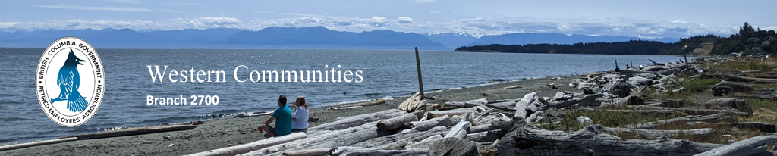

BCGREA Western Communities Branch 2700
Update August 15th, 2022
At the start of the month we had 78 members, with four on the interim executive. After a few planning sessions we have some ideas to share. Below is a schedule with dates for planned activities. A lot of details have been left off as we would like to get input from our members. The things we do and the speakers we invite, will be driven by what you want. So please come out to our first gathering on September 20th, 1pm at Gilbert Cade Memorial Hall, Langford 50 and Up Club, at 2637 Sunderland Road in Langford. Help us make things happen.
This get together will be part social and part brain storming. We are hoping for lots of suggestions so we can plan events to June of next year.
We are pleased to let you know that our webpage is now online. You can find it by going to www.bcgrea.ca and clicking on Branches, under which you will find the Western Communities. Here we will post the latest branch news and the calendar of events. There is a gallery of pictures on the bottom of the page taken at local sites. If you have other photos to add, please submit them on the link provided.
Agenda September 20th:
• Territorial Acknowledgement
• Minute of Silence
• Brief Membership and Financial update
• A synopsis of how the branch came about
• Brainstorming sessions
• Speakers
• Activities
• December yearend gathering
• Date and location of next meeting - November 15, 2022
• Adjournment
Refreshments by donation. * Door Prizes. * Meet and greet.
Building Covid requirements are you must wear a mask if unvaccinated.
Calendar:
September 20, 2022 | First General Membership Meeting | Gilbert Cade Hall 1:00
October 18-19, 2022 | AGM Provincial | Tsawwassen - Coastal Inn
October 25, 2022 | Outdoor activity | Location TBD
November 15, 2022 | General Membership Meeting | 1:00 Hall TBD
December 13? 2022 | Social event/lunch with membership | TBD
Your interim executive:
Co-Chair - Al Coccola
Treasurer - Tammy Welch
Secretary/Communications - Colleen Coccola
Membership - Valeska Campbell

