NANAIMO/MID ISLAND BRANCH #600
FALL NEWSLETTER 2023
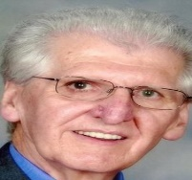
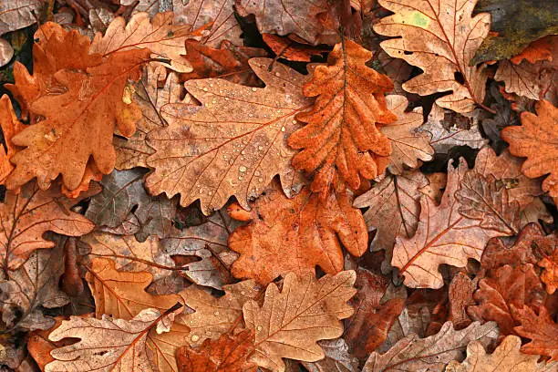

CHAIR’S REPORT - Lawrence Johnson

Here we are at the end of October and it looks like fall is here. That was a long dry summer but we were fortunate in that we didn’t have the same forest fire danger nor the smoke like our neighbours on the mainland especially in the interior. Myself being a retired employee of the B.C. Forest Service I have full sympathy for those that had to flee the flames and smoke and I am glad I don’t have to work fighting fires all summer any longer. Enough about me lets talk about our branch.

The Branch has its regular monthly meetings on the second Tuesday of each month at the Unitarian Hall at 595 Townsite Road here in Central Nanaimo. Our program director Lea Campbell has lined up some interesting speakers for November and January.
A representative from the Regional District of Nanaimo will talk at our November meeting about our transit system with some tips on how to make the system work for us.
In January Lea has lined up Mark Costales from Johnson Insurance to talk about travel and
home insurance along with an option to sign up for an online Pharmacy.

The branch provided a light lunch at our September meeting where we celebrated one of our members 100 Birthday, we all had a great time. You can read about Marina in a different article in this newsletter and also in the upcoming issue of the Provincial newsletter
“The Pen”.

We are selling tickets for our December 12th luncheon at the November membership meeting at a cost of $20.00 for members and $36.00 for non members. If you are unable to attend the November meeting you can contact Branch Treasurer Gloria Johnson at
250-616-3827 or via email: gloria.johnson.321@gmail.com for tickets.

The B.C.G.R.E.A. “Annual General Meeting” was held in Tsawwassen on October 18th, 2023, with some committee meetings held on the afternoon of Tuesday October 17th.
Our Branch was represented by myself as Branch Chair, along with Branch Directors
Lea Campbell, Warren McCormick, Roz Kennedy and Treasurer Gloria Johnson, who also attended the Treasurers meeting on Tuesday afternoon. Kathy Torhjelm, our branch secretary attended in her position as Provincial Secretary. The format of the AGM changed slightly in that most of the business portion was taken up before lunch and the keynote speaker was on the afternoon agenda along with elections.
Let’s deal with the elections first. The elections were chaired by Past President Ken Pendergast from Branch #1600 Prince George. Brian Green was returned by acclamation as Provincial President. There was one nominee for 1st Vice President as incumbent Vincent Sherry made the decision not to seek re-election. George Bowden from Branch #1200 Victoria was nominated and acclaimed as 1st Vice-President. The incumbent Patrick Harkness was acclaimed as 2nd Vice-President

The Keynote speaker was Tom Vincent the Chairperson of the B.C. Public Service Pension Plan Board of Trustees who gave us an overview of our pension plan. He assured us that the plan is in good standing and has the ability to provide pension benefits well into the future. He informed us that the Inflation Adjustment Account was also well positioned to provide inflation protection to all members, as it has done since in the account was put in place. He went on to say that after more than 25 years serving on Boards of Trustees first with the B.C. Teacher’s Pension Plan and the Public Service Pension Plan he will be stepping down as of March 31st, 2024. There was no indication of who his replacement might be.
In the morning we changed format and recognized members who had passed in the past year, not with a moment of silence but with a listing of their names and the branch they belonged to on the meeting room’s projection screens for all delegates to see. I found it quite moving as I personally recognized a few names.
We dealt with resolutions to change the association’s bylaws. First is was passed to recognize the Provincial Membership Secretary as a Provincial Table Officer. Next the proposal was to change the terms of the elected Table Officers from one year to multi-year terms. This resolution was defeated, therefore their terms of office will remain at one year. Next it was proposed that the non-elected Table Officers (Secretary, Treasurer and Membership Secretary) be changed to elected Table Officers. This resolution was also defeated. Those are the highlights of the AGM, if you need more details the meeting minutes will be posted on the association website in the near future.
Just a couple of more things from the branch… First of all I announced at the October membership meeting that this would be my last year as Branch chair and will be stepping down as of September 10, 2024. Now is your chance to become involved as our branch needs its members’ support. Secondly I hope to see you at the December 12th Christmas Luncheon, there will be fun, prizes and good food.
“Autumn shows us how beautiful it is to let things go.” – Unknown

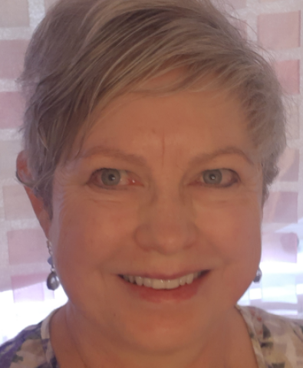
1st Vice - Lea Campbell
Autumn Greetings to all our Branch 600 Members. As the 2023 fall season shines let’s all enjoy the transitions of warmth and long days to our cooler and shorter days.
I continue to participate as a 1st vice, meeting the challenges of duties such as inviting
Guest Speakers and chairing meetings in Lawrence’s absence. A reminder, if you know of any speaker that may have an interesting topic, please let me know.

This past spring, once the snow had left Mount Benson and not returned for a week, we did plant several containers of vegetables and flowers, creating a nice garden area on our large back deck. Like many, I had hoped that by planting vegetables as well as flowers, it would help to stretch the grocery budget. Dreams of summer harvest and fresh bouquets! While it was enjoyable and satisfying to enjoy the harvest, it really didn’t stretch the budget.

I did enjoy attending the 2023 the AGM held in Tsawwassen in October. It was an interesting meeting and I enjoyed listening to the remarks made by the more “experienced” executives when discussing changes to the bylaws. I am recognizing more Executive members and appreciating the connections.

"Anyone who thinks fallen leaves are dead has never watched them dancing on a windy day." — Shira Tamir
Congratulations to Marina Krjivitsky on reaching your 100th birthday!
By Lawrence Johnson

I had the pleasure of interviewing Marina in May of this year to get her perspective on life and what she has experienced in the past 100 years.

Marina was born in September 1923 in Shanghai to parents who escaped Russia during the revolution. Her dad worked at the Ministry of Finance in St. Peterburg Russia and after escaping Russia became a banker in Shanghai living in the French sector. Her Dad, while on holiday, was so impressed with the clean fresh air of Victoria B.C. compared to Shanghai, that he decided that they should immigrate to Canada. Marina was 6 months old when the family moved to Vancouver Island to develop a farm outside of Ladysmith. The rent was affordable, the life style was healthy with fresh air, fresh vegetables, meat and seafood along with a spectacular ocean view.

The family stayed on the farm until she reached the age of 14. Following the death of her father the family moved to Vancouver. Marina graduated from Britannia High School in 1943 and then enrolled at a Business College in downtown Vancouver taking bookkeeping and took a short hand course at night school. Marina then went to work for B.C. Electric and then B.C. Hydro.
She loved to travel and bought a “cross Canada” rail ticket, which allowed her to get off and on the train where she pleased and to cycle the more scenic parts of Canada. You had to use a bike to get around during the Second World war due to rationing of gasoline. She joined the International Hosteling Association, her love of travel took her to Europe staying at youth hostels and being able to see classic opera and ballet performances for $1.50 each.
Marina said that because the Canadian dollar was very strong after WWII it was cheaper to travel in Europe than to live in Canada. She remembers traveling to Micronesia (Marshall Islands to Guam) spending most of her time snorkeling and still remembers the colorful coral and tropical fish. Another memorable adventure was a solo trip to India for seven weeks and the wonderful time she had.

Later Marina moved to Montreal and worked for R.C.A. She went to MGill University attending night school and learned to speak Spanish.

Marina decided that she needed to have a pension when she retired so she went to work for the B.C. provincial government at the Vancouver Law Courts, first in the “Black Tower” at Granville and Georgia and later at the present day location on Robson Street. Her memory of work is that she worked for supportive supervisors.

Marina retired at age 65 and continued traveling including adventures closer to home on Vancouver Island. She fondly remembers a 15 mile hike to Cape Scott on Northern Vancouver Island, a hike that will be remembered for it’s awe-inspiring natural beauty. She moved to Nanaimo in 1991 and heard about the Nanaimo Branch of the B.C.G.R.E.A. and was told that branch was a nice group. She has enjoyed her membership over the past thirty five years attending most monthly meetings and social events.

She attributes her long life to her love of nature, to downhill skiing, along with swimming almost daily in the ocean which is a little harder to do now with poor eyesight and balance issues.
Her appreciation of nature helps her keep a positive happy outlook and to enjoy life.

Thank you Marina for sharing your life experience we wish you all the best and hope you are able to continue to live life without regret.
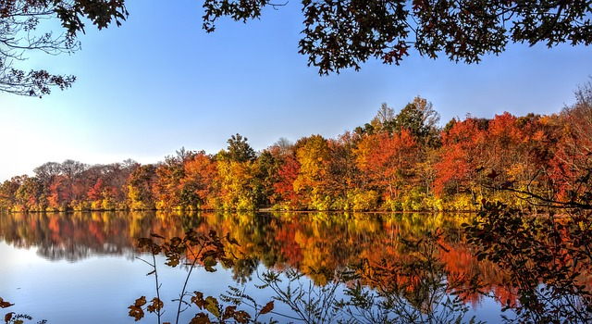

Membership Chair - Warren McCormick
Branch 600 Nanaimo/Mid-Island membership continues to grow over the latest period. Members should be aware that they can access their profile on the bcgrea.ca site by clicking the MEMBERS tab and signing in with email and password. From the next page you can update the usual info such as address and phone numbers, etc. On that page if you click the MEMBERSHIP tab you will see a page with your membership info and a membership card (on the right side of the white area). Under your name you should see your Pension Corp ID number. If you do not see your number, you can find it by signing on to the Pension Corp website (pensionsbc.ca) or by looking at any paperwork from the Pension Corp. (i.e. tax forms). You should then send your Pension Corp ID number to the BCGREA using the CONTACT US form. This will help BCGREA track members better.

Support your branch by coming out to events.

“Autumn carries more gold in its pocket than all the other seasons.”
― Jim Bishop

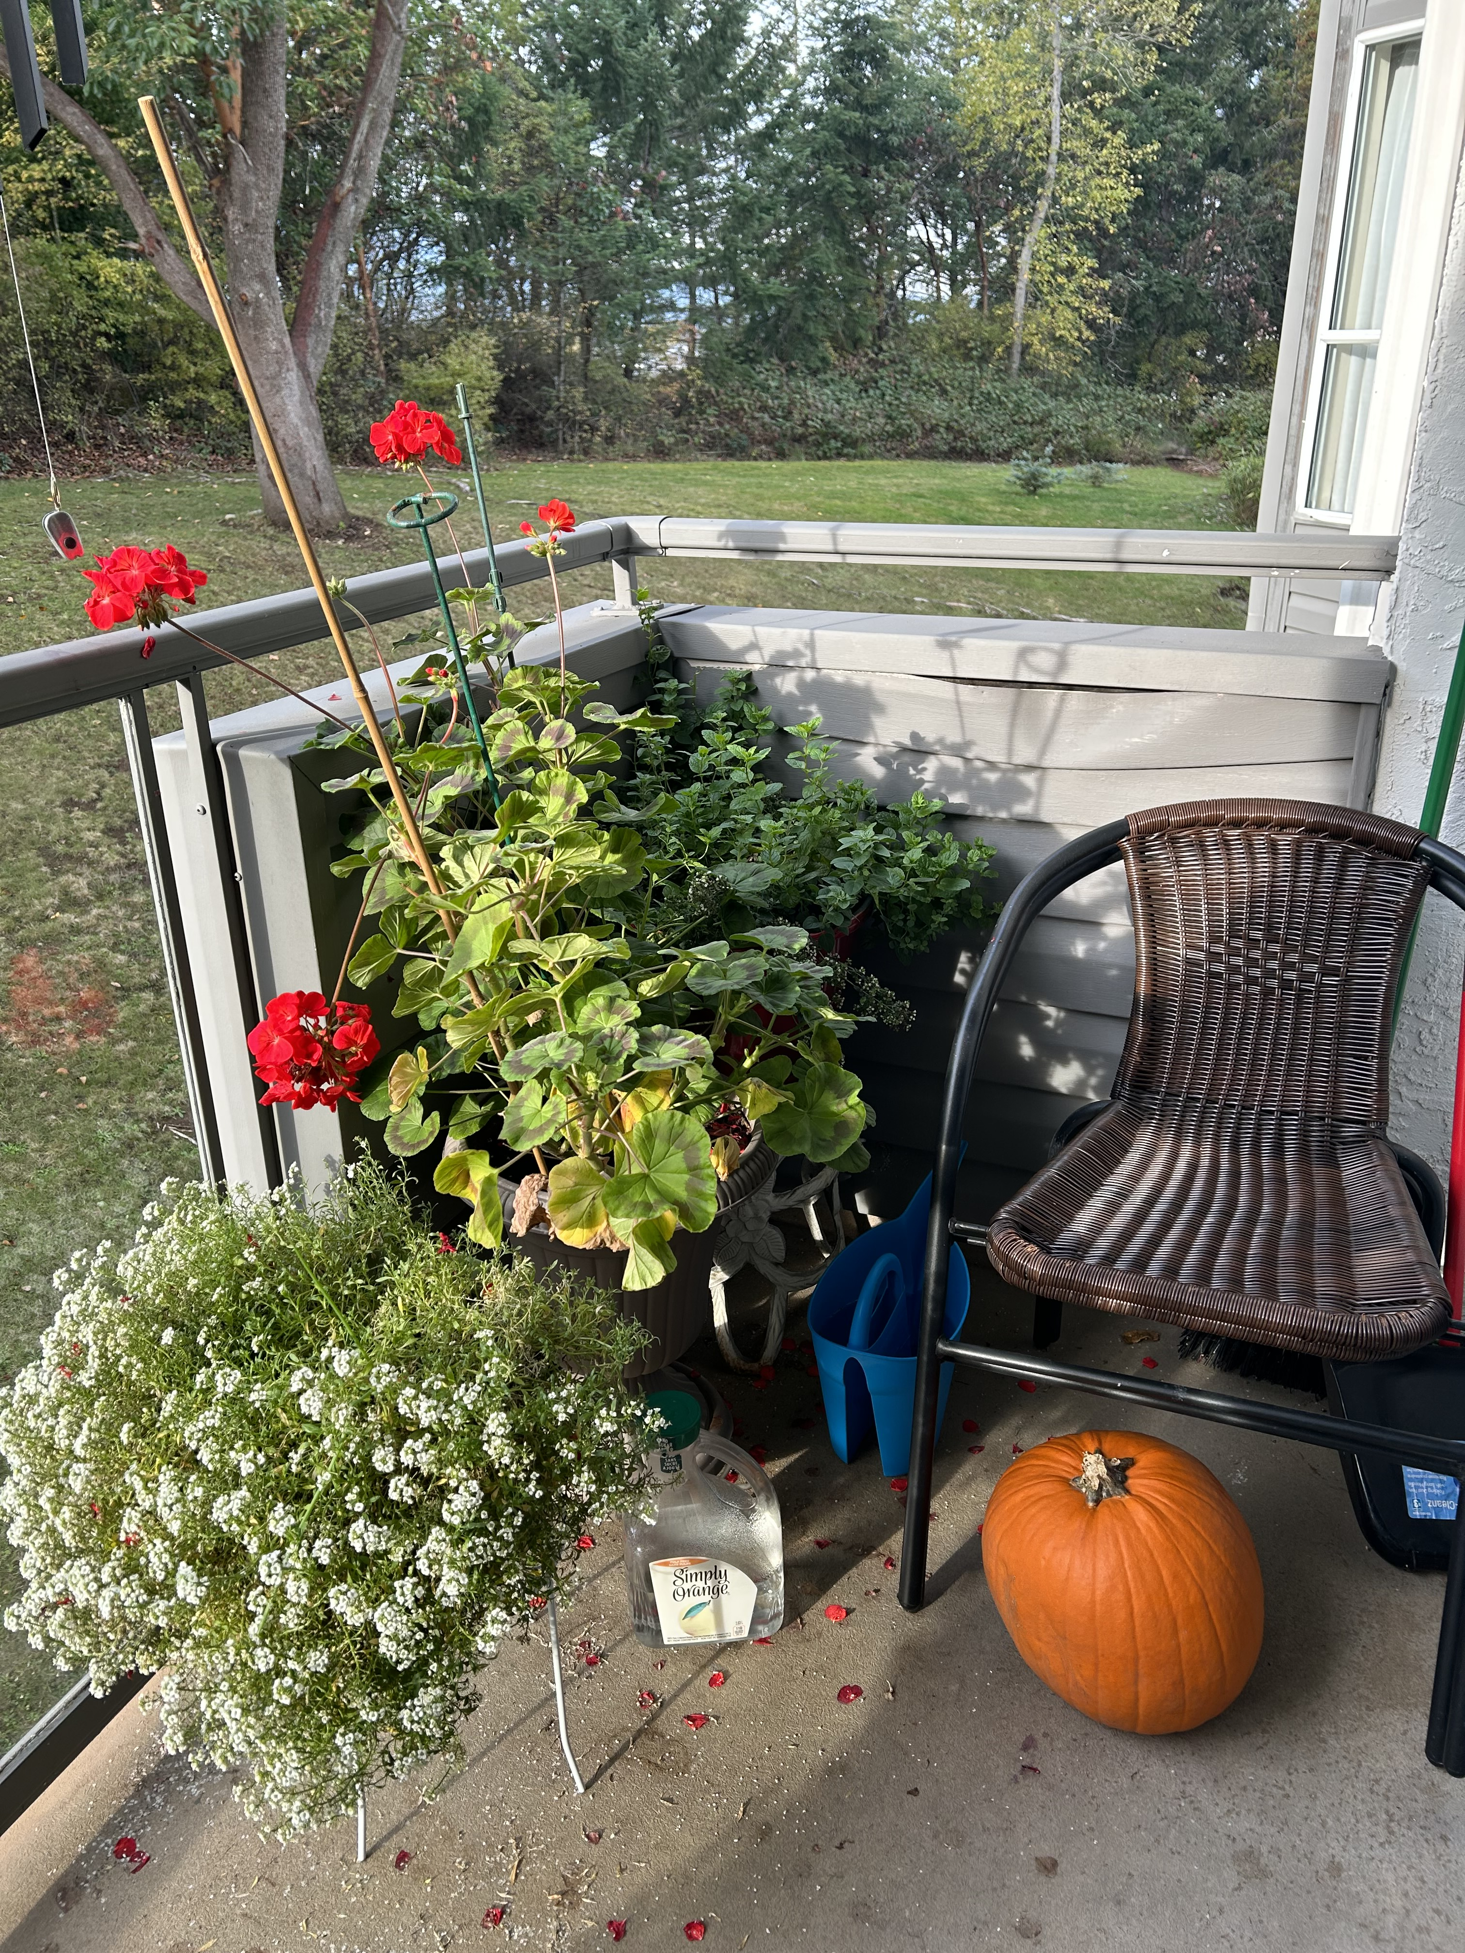

Director of Special Events - Maria Noel

I live in an apartment style home and one of my hobbies is gardening. Limited by space, I try my hand at pot gardening. This year my geraniums were absolutely stunning and grew so tall! As you can see in the pictures, autumn has arrived and they are beginning to heed the call of the cooler weather.
As we all begin to put on our outer wear, some plants just go dormant. Some of our seniors also go into hibernation as winter approaches. I am grateful for my caring neighbors and friends. So remember, people too, like plants, need some love and attention. So don’t forget those who don’t get out much in winter. Give them a call and say hello. Better yet pick them up and go on an outing, even if it is just for coffee.
I’d like to remind everyone that Remembrance Day, November 11th, is coming up soon. Legions 10, 256, and 257 are providing a gathering place, and offer food and music for an interesting day, so check them out and let us remember those who have gone before us and paid a price for our current freedoms.
Please come out and enjoy the Christmas Luncheon, our last lunch of 2023 together.
Meet some new people and have some fun. You might even Win a Door Prize!

“I'm so glad I live in a world where there are Octobers.”
― L. M. Montgomery, Anne of Green Gables

Roz Kennedy

Never too old to get out and enjoy nature, camp and socialize when you belong to an ATV club.
In my role as a Director I will be assisting Lea with hosting the meetings in Lawrence’s absence. I am still interested in member feedback as to what kind of speakers or
presenters the membership would like to hear at our monthly meetings. Be it political, health related, senior service or hobbies and if you or someone you know has an interesting presentation please let me know.

“There is something incredibly nostalgic and significant about the annual cascade of autumn leaves.”
― Joe L. Wheeler

**********************************************************

Buddy Callers/ Telephone Committee - VACANT

The role of the Telephone Committee Coordinator in the Executive is to gather the information for the upcoming meeting to pass on to the Committee members. As the people we contact do not receive email notifications, we also relay other important information such as changes to benefits or specials from partner companies.
If you would like to volunteer for this position, please let any Executive Member know!
Benefits and Reasons to be a BCGREA Member:
**Keep informed of what is happening with our pension issues through
discussion and newsletters.**
**Socialize, meet new friends and former colleagues.**
**Have a voice in our organization.**

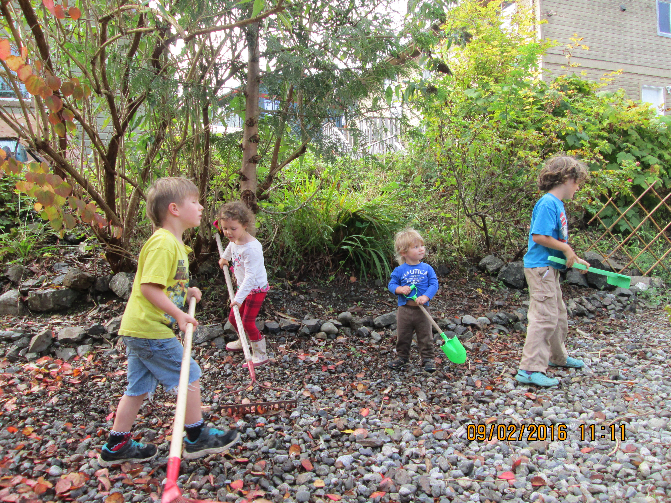

***PLEASE GET INVOLVED!***
Membership Meetings

The 2nd Tuesday of Jan, Feb, Mar, Apr, May == Sep, Oct, Nov

at The Unitarian Fellowship Hall – 595 Townsite Road

1:30 pm – 3:00 pm

Chair – Lawrence Johnson 250-816-0113
1st Vice– Lea Campbell 250-756-2587
Secretary – Kathy Torhjelm 250-753-5778
Treasurer – Gloria Johnson 250-616-3827
Membership – Warren McCormick 250-390-1068
Director of Special Events – Maria Noel 778-268-4514
Director – Roz Kennedy 250-682–5820

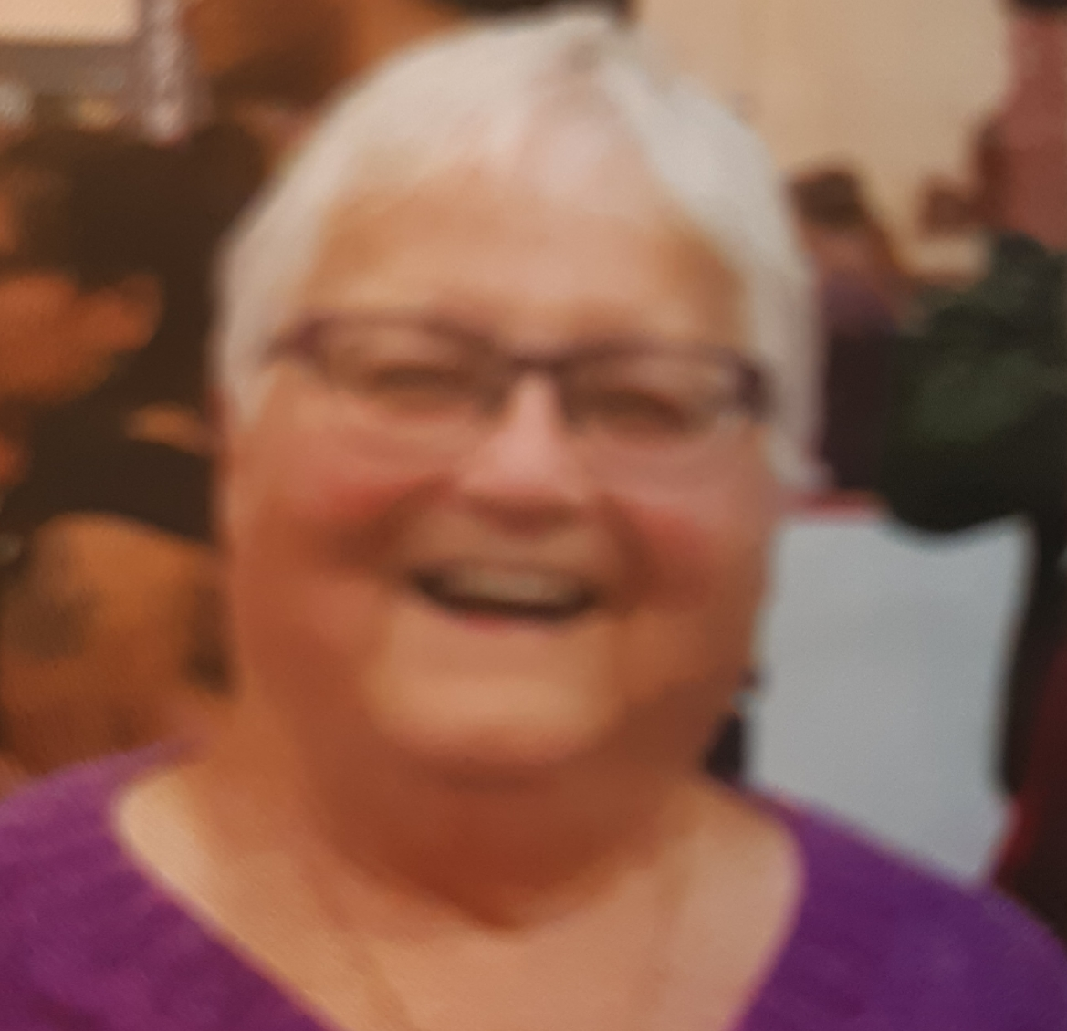

Kathy Torhjelm – Secretary
Apple Cranberry Crumble Muffins

Topping:
¼ c packing brown sugar 1/4 chopped almonds
3 T oats 1 tsp cinnamon
1-2 T margarine/butter, melted
- Combine all ingredients and mix well.
Muffins:
2¼ c flour
1½ c packed brown sugar
1 tsp baking soda
1 egg
1 c plain yogurt
½ c oil
2 c diced, peeled apples
¾ c cranberries
- Combine flour, brown sugar and baking soda in large bowl.
- Combine egg, yogurt and oil in small bowl.
- Add to dry ingredients stirring just until moistened. Batter is thick.
- Stir in apples and cranberries.
- Use baking cups to line the muffin pan makes it easier to remove from pan.
- Heap muffin cups with batter. Sprinkle with topping.
- Bake at 375F for about 25 minutes.
- Makes 12 muffins. Freezes well.

“Autumn that year painted the countryside in vivid shades of scarlet, saffron and russet, and the days were clear and crisp under harvest skies.” ― Sharon Kay Penman, Time and Chance

***BCGREA CHRISTMAS LUNCH***
Tuesday, December 12, 2023

Branch 256 Legion on Bowen/Townsite Road

Doors open at 12:00 with lunch served at 12:30

Lots of Door Prizes to be Won

Members of BCGREA Branch 600 $20
Non-members $36

Contact Gloria Johnson at 250-616-3827 or gloria.johnson.321@gmail.com

Deadline for purchasing Lunch tickets is Monday, December 4, 2023

IN MEMORY

Thomas Bayer

James Dolling

Edna May Donaldson

Melvin P Gow

Catherine Griffin

Lee Montgomery

“What is lovely never dies, but passes into another loveliness, star-dust or sea-foam, flower or winged air.”
—Thomas Bailey Aldrich

